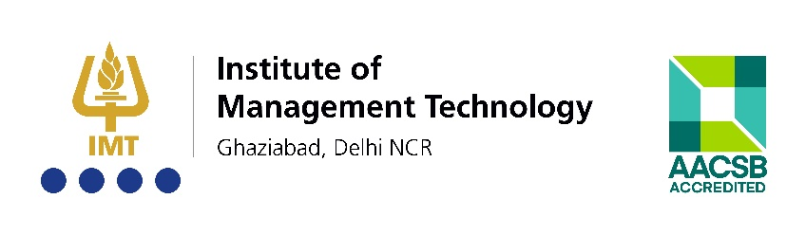
Media Release
IMT Ghaziabad Launches India’s First CMTOnet with Industry and Alumni
Ghaziabad/New Delhi | February 7, 2018
IMT Ghaziabad (IMTG), India’s premier management school with a distinct focus on grooming Leadership through Innovation, Execution and Social Responsibility, launches India’s first CMTOnet with industry and alumni on February 7, 2018. The CMTOnet was unveiled at a conclave organised by the Digital Marketing and Consumer Insights (DMCI) Committee of the institute. With an objective to provide a platform for deliberating on contemporary marketing challenges and draw a charter of future roadmap for sales and marketing professionals to stay relevant, the Conclave on the topic “Marketing in the Age of Experience”, witnessed amalgamation of senior industry leaders representing corporates like TCS, Genpact, Reckitt Benkiser, Gazelle, JLL, Tata Motor, RCOM, PayTM, HCL, Panasonic, etc.
Unveiled at the Conclave, the CMTOnet is a platform for academia and industry to collaborate in technology marketing domain. IMT Ghaziabad is collaborating with the top marketing minds in the industry who are excelling in applying technology to marketing practices. Speaking on the occasion, Dr. Atish Chattopadhyay said, “IMT Ghaziabad has invested in building world-class facilities like Real Time Contextual Marketing Lab, Media Lab, Analytics Lab and put together a team of highly experienced faculty to advance the practice of digital marketing, analytics and customer insights mining. We want to take this practice beyond the classroom walls for India Inc. and marketing professionals to stay competitive. This CMTOnet aims to facilitate the exchange of knowledge and best practices among the academia and industry fraternity and build thought leadership assets to promote the practice in the country.”
Prof Asit K Barma, Chair- Digital Marketing and Consumer Insights Area said, “With increasing use of AI and analytics, the marketing warfare has assumed a different hue in today’s platform era. Chief Marketing Officers are evolving into the role of Chief Marketing Technology Officers! IMT is collaborating with the top marketing minds in the industry with many of them being our alumni excelling in applying technology to marketing practices. DMCI conclave will be an annual flagship event of IMT Ghaziabad. IMTG will continue to build consensus through sharing its points of views from time to time on contemporary issues in DMCI space. These points of views will be shared in the form of lectures, presentations, case studies, published research papers.”

The speakers at the Conclave included Mr. Pankaj Renjhen, Managing Director-Retail Services, JLL India; Mr. Rohit Tiku, Sr. Vice President & Business Head- North, TATA Motors Finance Ltd.; Mr. Kirit Goyal, Director, Gazelle; Ms. Bhavana Mittal, Regional Head (Digital & Communications),Reckitt Benkiser, South Asia; Mr. Vikram Kher, Category Head - Amazon India (Consumer Electronics - Camera, Wearable, Storage Devices, Printers & Office Products; Ms. Neha Anand, Global Head- Digital, Content & Thought Leadership, Marketing and Managing Editor, Straight Talk & StraightTalkOnline.com; Mr. Sharad Bhargava, Leader - Digital Strategy and Next Gen Experience Solutions, Tata Consultancy Services; Mr. Sundip Gorai, Vice President & Head of Business - Data Sciences, Artificial Intelligence (AI), Analytics, EIM (BIDW+Big Data) & Author, GENPACT; Mr. Devesh Singhal, Associate Director, Panasonic India Pvt. Ltd.; and, Mr. Sujai Srivastava, RCOM.

---------------------------------------------------------------
About IMT Ghaziabad
Established in 1980, Institute of Management Technology, Ghaziabad (IMTG) is India’s premier AACSB accredited management school with a distinct focus on grooming Leadership through Innovation, Execution and Social Responsibility. An autonomous, not–for–profit institute, offering highly sought–after postgraduate programmes over the past more than three–and–a–half decades, IMTG currently offers four AICTE approved programmes – Post Graduate Diploma in Management (PGDM) Full Time, PGDM Executive, PGDM Part Time, and PGDM Dual Country Programme (DCP). While the first three programmes are offered at the IMTG campus in Ghaziabad, Delhi NCR, India, the PGDM DCP is offered in collaboration with IMT Dubai campus. The Post Graduate Programme in Management (PGPM) is the latest addition to the list which leads to PGDM Part Time. IMTG has been consistently ranked among the top management institutes of the country for its Leadership, Faculty, Research, Student Selection Process, Curriculum, Pedagogy, Industry Interface, Internationalism, Placements, and Infrastructure.
Today, IMTG is the proud alma mater of more than 300 C–suite executives and thousands of professionals serving in leadership positions in the best-known organisations in India and the world, in key business functions of Sales, Operations, Human Resources, Consulting, Information Technology, Marketing, and Finance among others.
More at www.imt.edu.
---
Media Contact
Himanshu Dandotiya, Manager – Digital Marketing | hdandotiya@imt.edu | 9558808618

